UNVEILING THE VIRTUAL CLASSROOM: AN IN-DEPTH ANALYSIS OF THE ONLINE EDUCATION SYSTEM

# INTRODUCTION:

* 1. **Overview:**

The emergence of online education and virtual classrooms has been accelerated by the COVID-19 pandemic, offering a lifeline to students seeking continued learning during challenging times. The transition to online classes brought both opportunities and challenges, leading to a profound impact on the education system. This projects goal is to shape a more inclusive, engaging, and effective learning environment in the digital age, contributing to the ongoing dialogue on the future of education. This project proposal outlines a comprehensive analysis of online education and its impact on students, teachers, and the education system as a whole.

The sudden shift to virtual classrooms brought both opportunities and challenges for educational institutions, policymakers, and online learning platforms. Understanding the strengths, weaknesses, opportunities, and challenges of online education is crucial for making informed decisions to enhance its effectiveness and accessibility.

# Purpose:

The main objective of this project is to provide valuable insights into the strengths, weaknesses, opportunities, and challenges of online education. The ultimate goal is to contribute to the improvement of online education methods and platforms, making them more effective, accessible, and engaging for learners in the digital age. The business aims to enhance the effectiveness of online education to ensure that students achieve their learning objectives and retain knowledge at a level comparable to traditional classrooms. It is essential to equip educators with the necessary skills and training to effectively conduct online classes, utilize digital tools, and engage students in virtual environments. The business requires a robust technological infrastructure to support online learning, including reliable internet connectivity, access to digital devices, and secure platforms for virtual classrooms.

# LITERATURE SURVEY:

Over the past decade, the integration of technology in education has brought about a transformative shift, with online platforms becoming indispensable tools for learning (Almahasees and Jaccomard, 2020). The emergence of the COVID-19 pandemic expedited this transition, compelling educational institutions to swiftly adopt online learning methods, presenting both challenges and opportunities.

In the face of the crisis, online learning has demonstrated its value as a crucial solution to maintain educational continuity (Dhawan, 2020). It has proven to be a lifeline during emergencies, emphasizing the need for educational institutions to invest in robust technical infrastructure and provide comprehensive IT skills training to faculty and students (Nikdel Teymori and Fardin, 2020). However, amid the advantages, concerns

surrounding data privacy and cybersecurity have surfaced, necessitating a heightened focus on protecting students' private information in the digital realm (Luxatia, 2020).

Faculty and students alike have recognized the benefits of online learning, such as flexibility and cost-effectiveness (Gautam, 2020). Nevertheless, they have also encountered challenges, including technical issues and limited opportunities for interaction. Addressing these obstacles and optimizing the potential of online learning will be critical to providing high-quality education in the evolving digital landscape (Cheng and Chau, 2016).

As education continues to evolve, embracing technology and adapting to its advancements will be essential for both educators and learners. By fostering a dynamic learning environment and equipping stakeholders with the necessary skills, educational institutions can fully leverage the power of technology to enhance the overall learning experience, even beyond the challenges posed by unexpected crises.

# Proposed Solution

The social impact of this analysis is multifaceted. Enhancing accessibility in online education can bridge the educational gap and create equal opportunities for students from diverse backgrounds. From a business perspective, gaining insights into the challenges faced by students and teachers in online education can drive the development of innovative solutions and services. Online learning platforms and educational technology providers can tailor their offerings to meet the specific needs of learners and educators, leading to increased market competitiveness.

The proposed system seeks to leverage the robust capabilities of IBM Cognos Analytics to revolutionize education by providing comprehensive data analysis and visualization tools. By integrating this powerful platform, educational institutions can unlock valuable insights into student performance, course effectiveness, and overall learning outcomes. Through interactive dashboards, predictive analytics, and adaptive learning features, educators and administrators gain the ability to make informed decisions, optimize resource allocation, and personalize student experiences. This data-driven approach not only enhances educational quality but also fosters a culture of continuous improvement, ultimately shaping a more effective and engaging learning environment.

# THEORETICAL ANALYSIS:

* 1. Block diagram

IBM Cognos Analytics



Web

Story

Visualization

Dashboard

Pre- processing

Dataset

Figure: 1 Block Diagram

The block diagram of the proposed system is given in figure 1. The input dataset is collected and input to IBM Cognos Analytics tool.

# Data Collection: Gathering the Dataset

The first step involves collecting relevant data from diverse sources, such as student records, attendance logs, exam results, and course materials. This data may exist in various formats, including spreadsheets and databases. The dataset is in a csv file format.

# Data Preparation

Next, IBM Cognos Analytics comes into play. It enables the connection of these data sources. Through this process, IBM Cognos provides connectors that facilitate the import and organization of data in a centralized manner.

# Data Preparation for Visualization

Once connected, the data might require cleaning and transformation for accuracy and consistency. IBM Cognos equips tools to cleanse, filter, and manipulate data. These tools facilitate tasks such as removing duplicates, rectifying errors, and formatting data as needed.

# Creating Data Visualizations:

IBM Cognos Analytics offers a versatile array of tools to create diverse data visualizations. These encompass bar charts, line graphs, pie charts, and more. The choice of visualizations hinges on the specific insights to be conveyed. Within Cognos, we can effortlessly select data, choose chart types, and customize colours and labels to craft engaging and comprehensible representations.

# Dashboard Development:

Cognos empowers to design interactive and responsive dashboards. Within these dashboards, visualizations, charts, and tables are arranged strategically. The inherent responsive design ensures optimal performance and appearance across an array of devices, spanning computers, tablets, and smartphones.

# Building the Story

IBM Cognos Analytics enables the creation of dynamic data narratives via a sequence of scenes. Each scene encapsulates a distinct facet of the analysis or data story.

IBM Cognos Analytics furnishes a user-friendly interface featuring intuitive drag-and- drop functionality. Through data collection, preparation, visualization, dashboard creation, and storytelling, the platform facilitates the transformation of data into actionable knowledge.

# EXPERIMENTAL INVESTIGATIONS:

The experimental investigations yield actionable insights into the potential impact of IBM Cognos Analytics on online education. By analyzing student performance, predicting areas of concern, and tailoring learning experiences, the project aims to

enhance the overall quality of online education. The use of interactive dashboards and storytelling techniques ensures that the findings are effectively communicated to educators, administrators, and policymakers, facilitating evidence-based decision- making.

By harnessing the capabilities of IBM Cognos Analytics, this project aims to contribute to the ongoing dialogue on educational innovation and cultivate a more dynamic and effective learning environment in the digital age.

# FLOW CHART

The key steps and elements for the experimental investigations using IBM Cognos Analytics in the context of enhancing online education is shown in the flow chart given in Figure 2.

**Start**

**Data Collection and Integration**

**Data Analysis and Visualization**

**Interactive Dashboards and Storytelling**

**End**

**Outcomes**

Figure 2. Flow chart

# RESUTS:

The results obtained on each steps is given in screenshots.

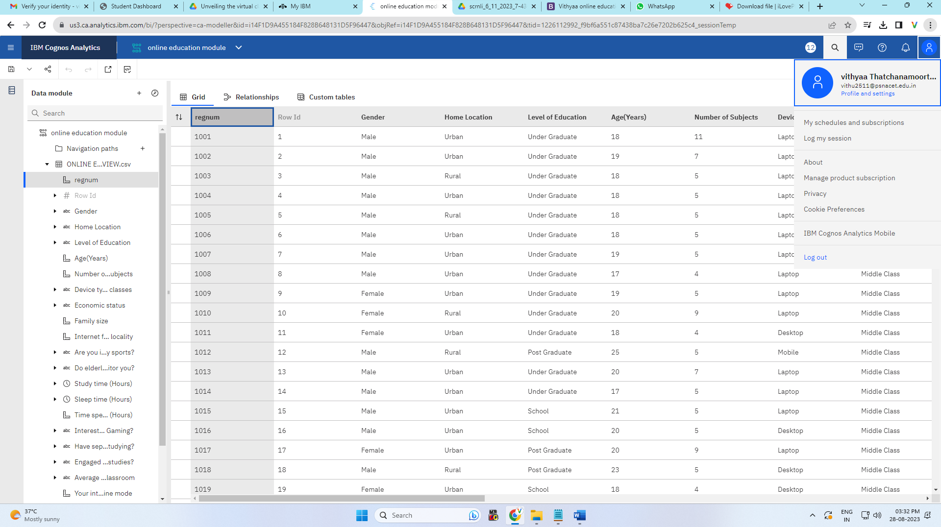

Figure 3.Online education dataset csv file viewed in the IBM Cognos tool Exploration tool is used to create beautiful visualizations

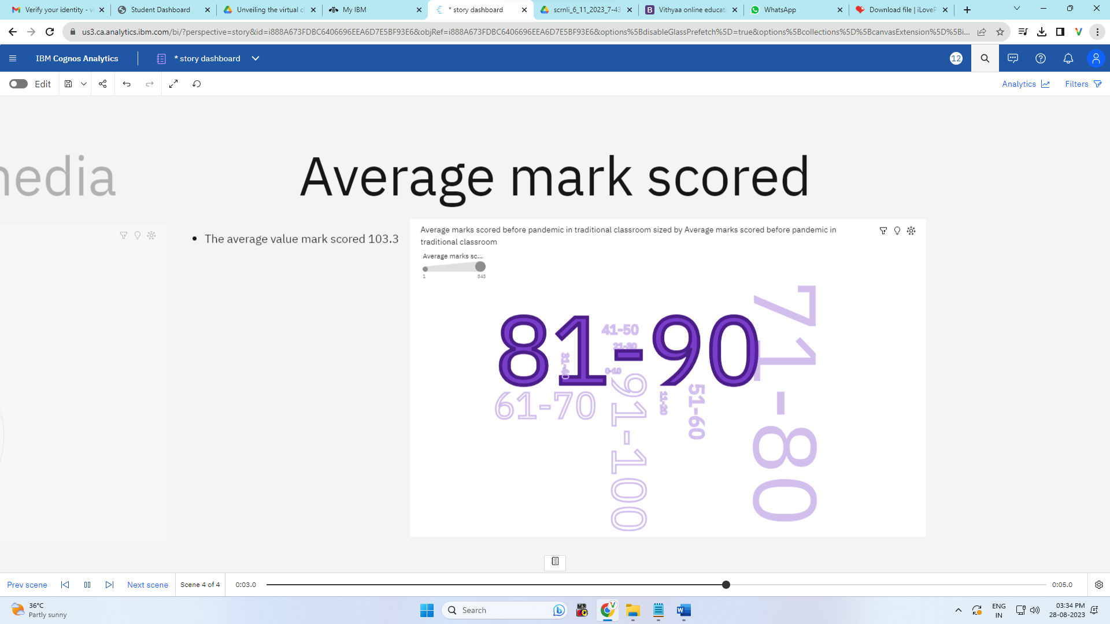

Figure 4.Average mark score and Level of satisfaction plotted using IBM Cognos Analytics tool

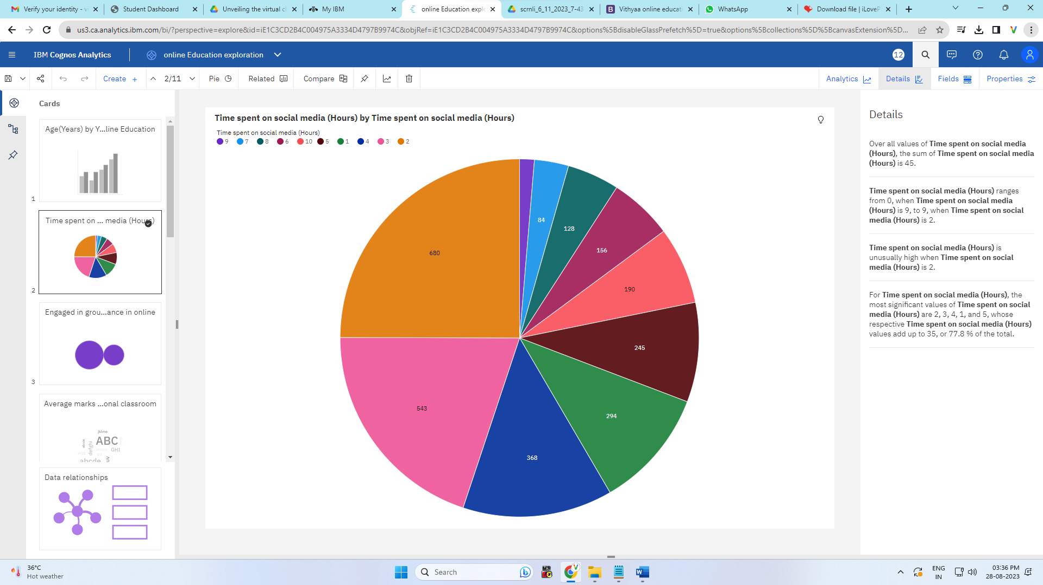

Figure 5.Pie chart between Time spent on social media and device used plotted using IBM Cognos Analytics tool

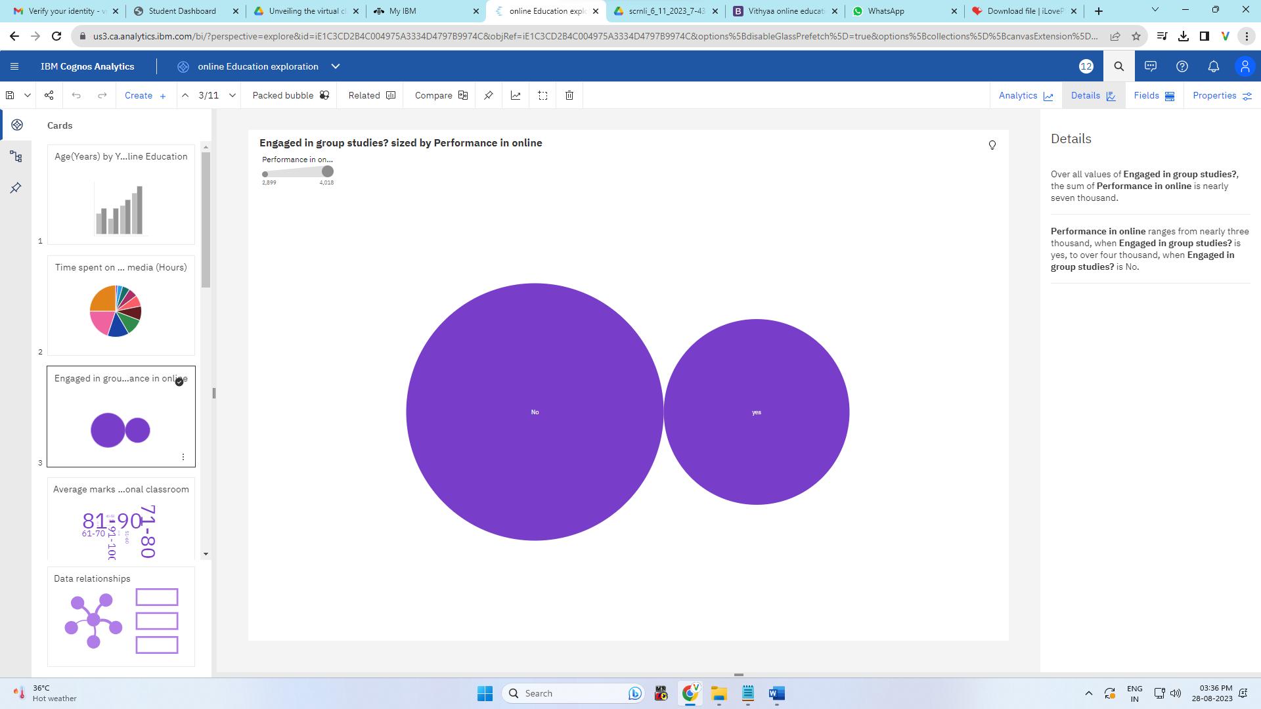

Figure 6. Bubble chart between engaged in group studied and performance plotted using IBM Cognos Analytics tool

Dashboards: 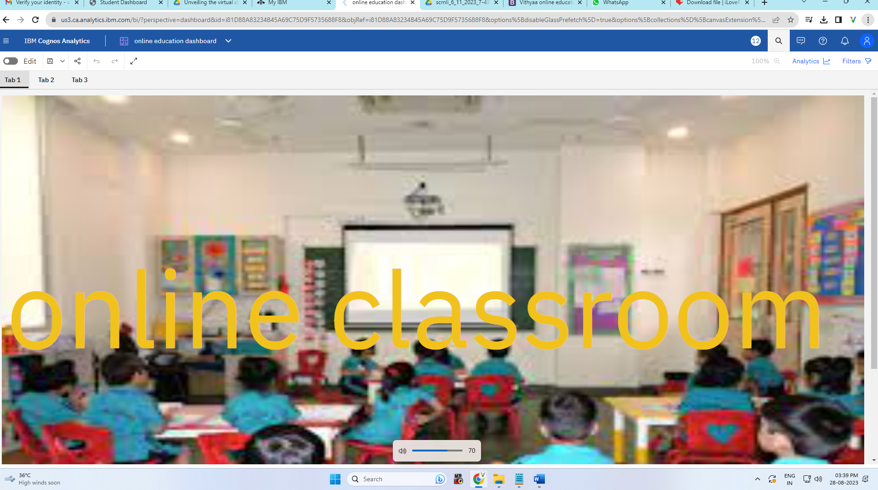

Figure 7. Dashboard showing several visualization on Tab1 using IBM Cognos Analytics tool

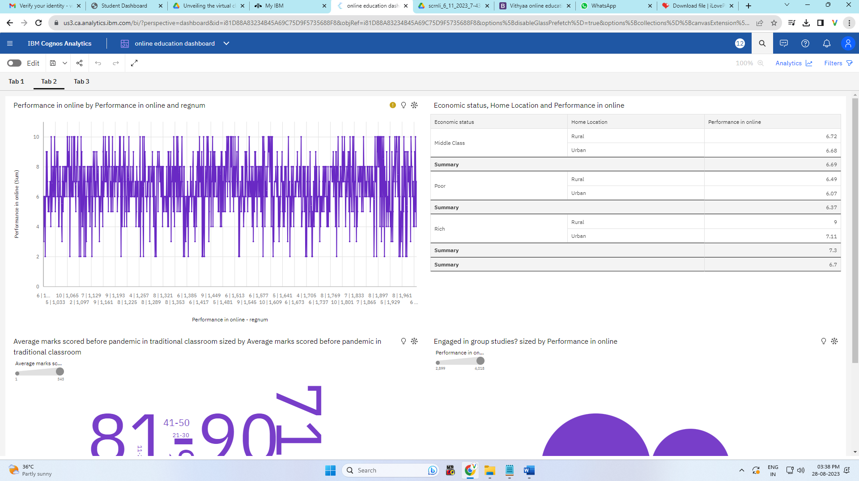

Figure 8. Dashboard showing several visualization on Tab2 using IBM Cognos Analytics tool

Story

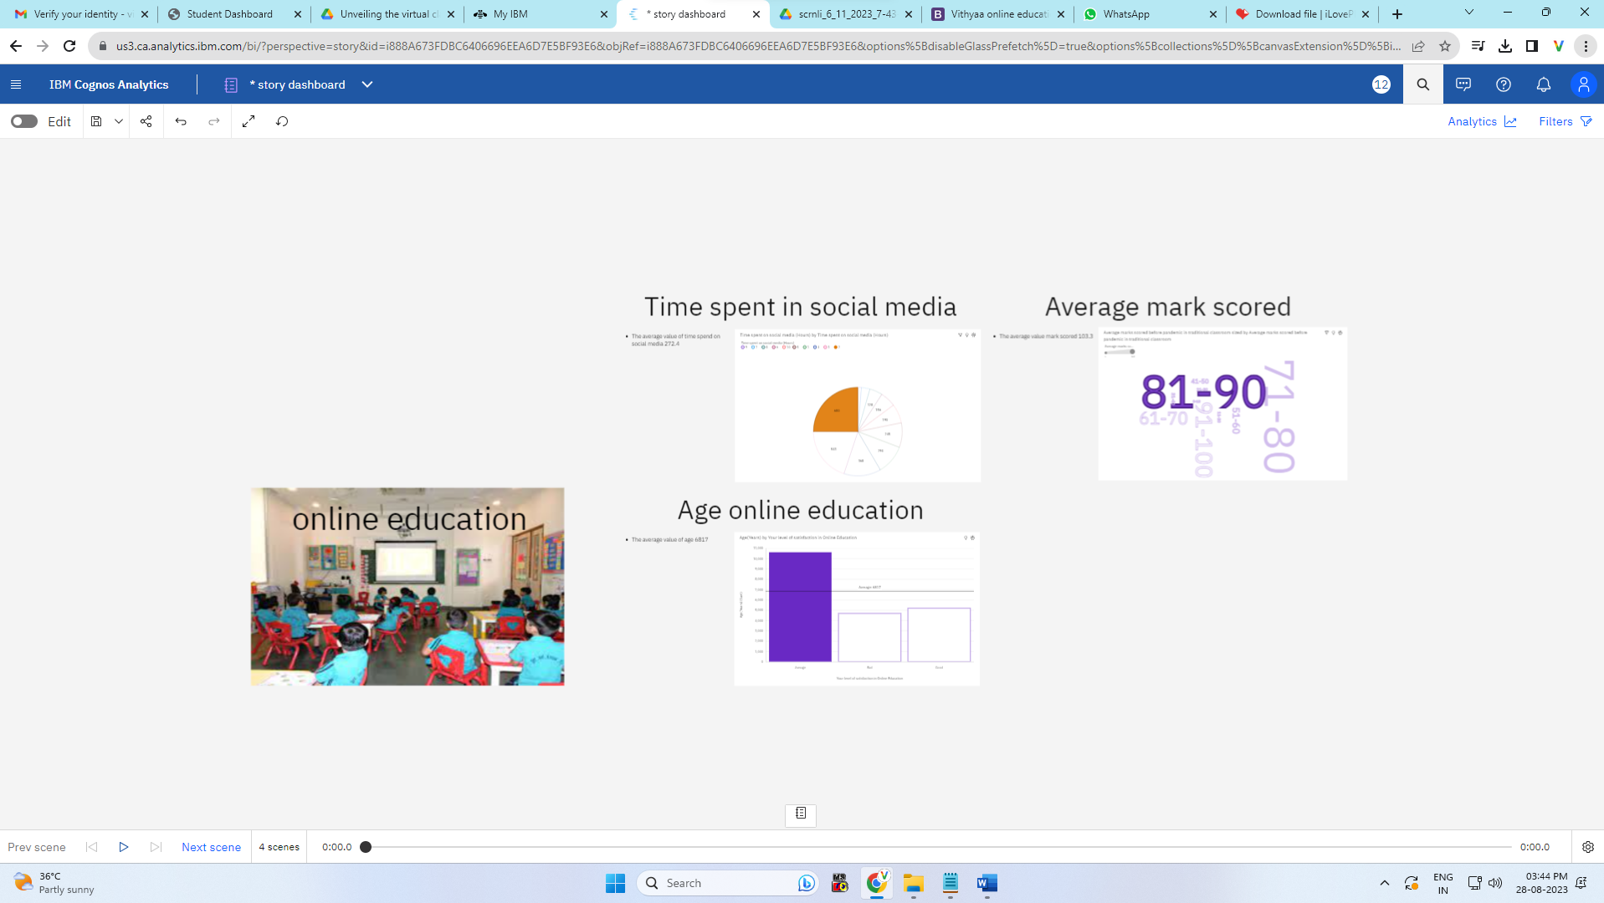

Figure 9. Story created using IBM Cognos Analytics tool

Report

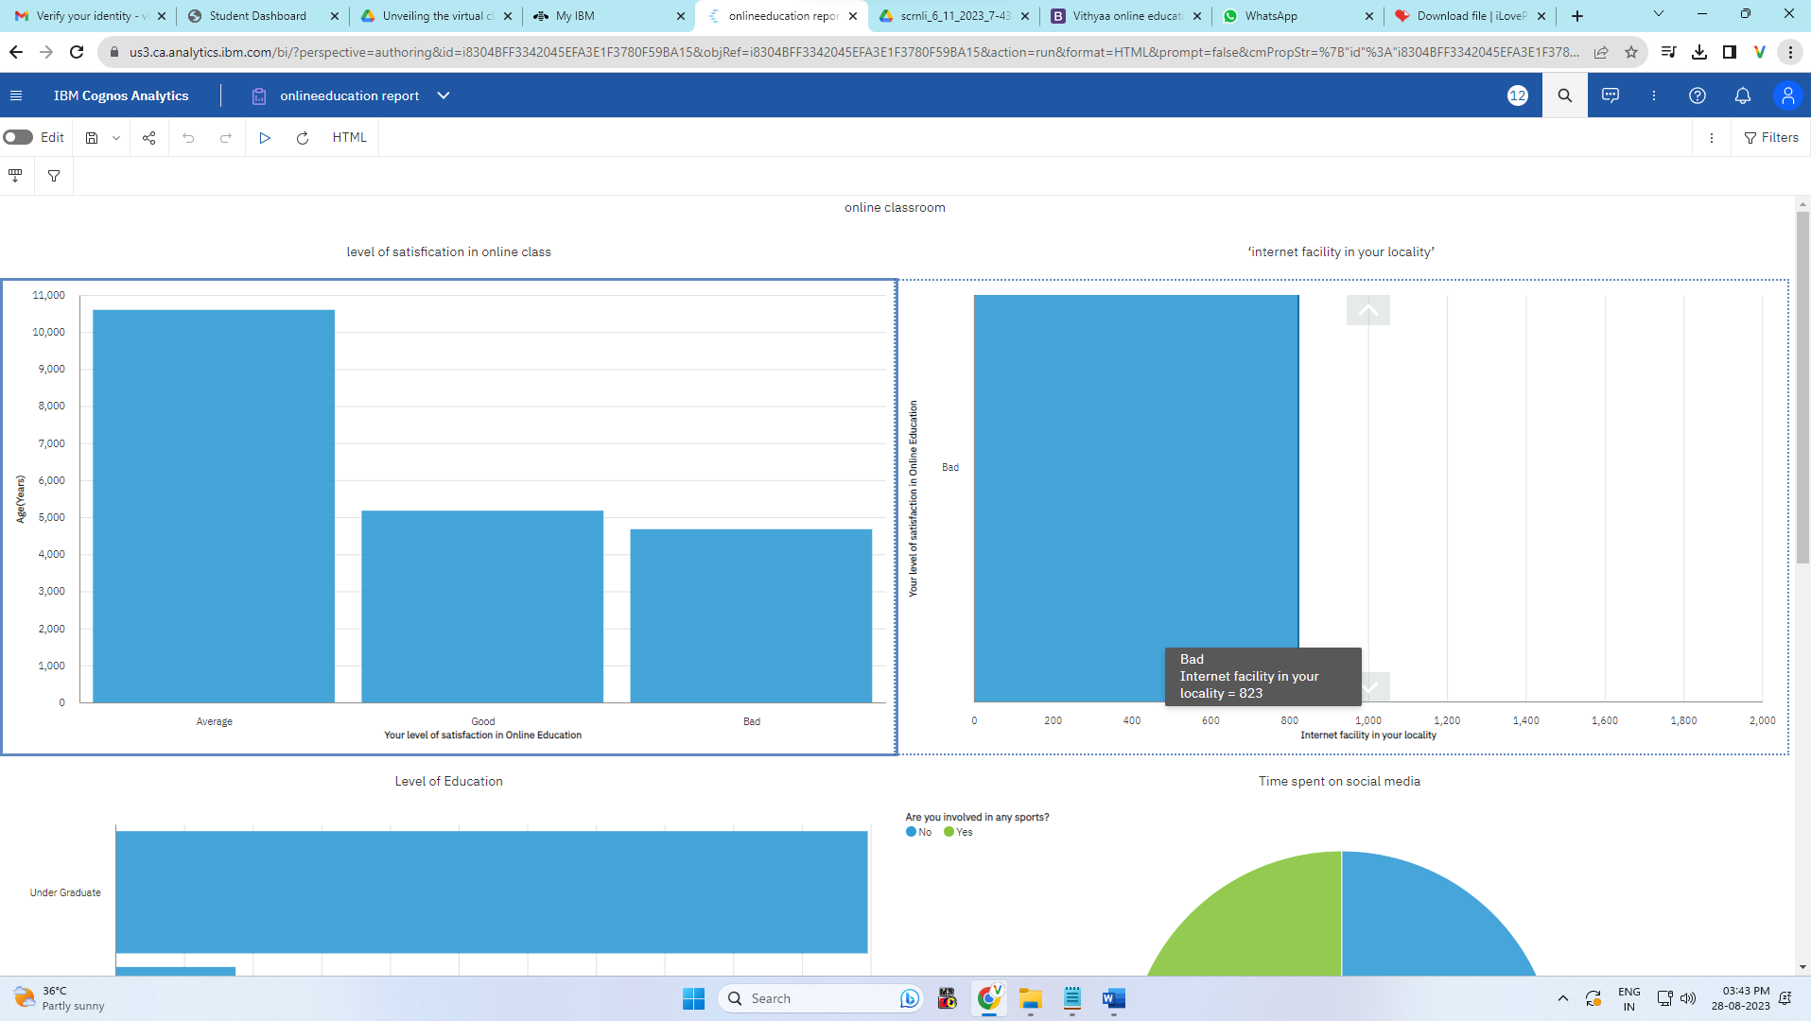

Figure 10. Report generated using IBM Cognos Analytics tool

Website:

<http://127.0.0.1:8000>

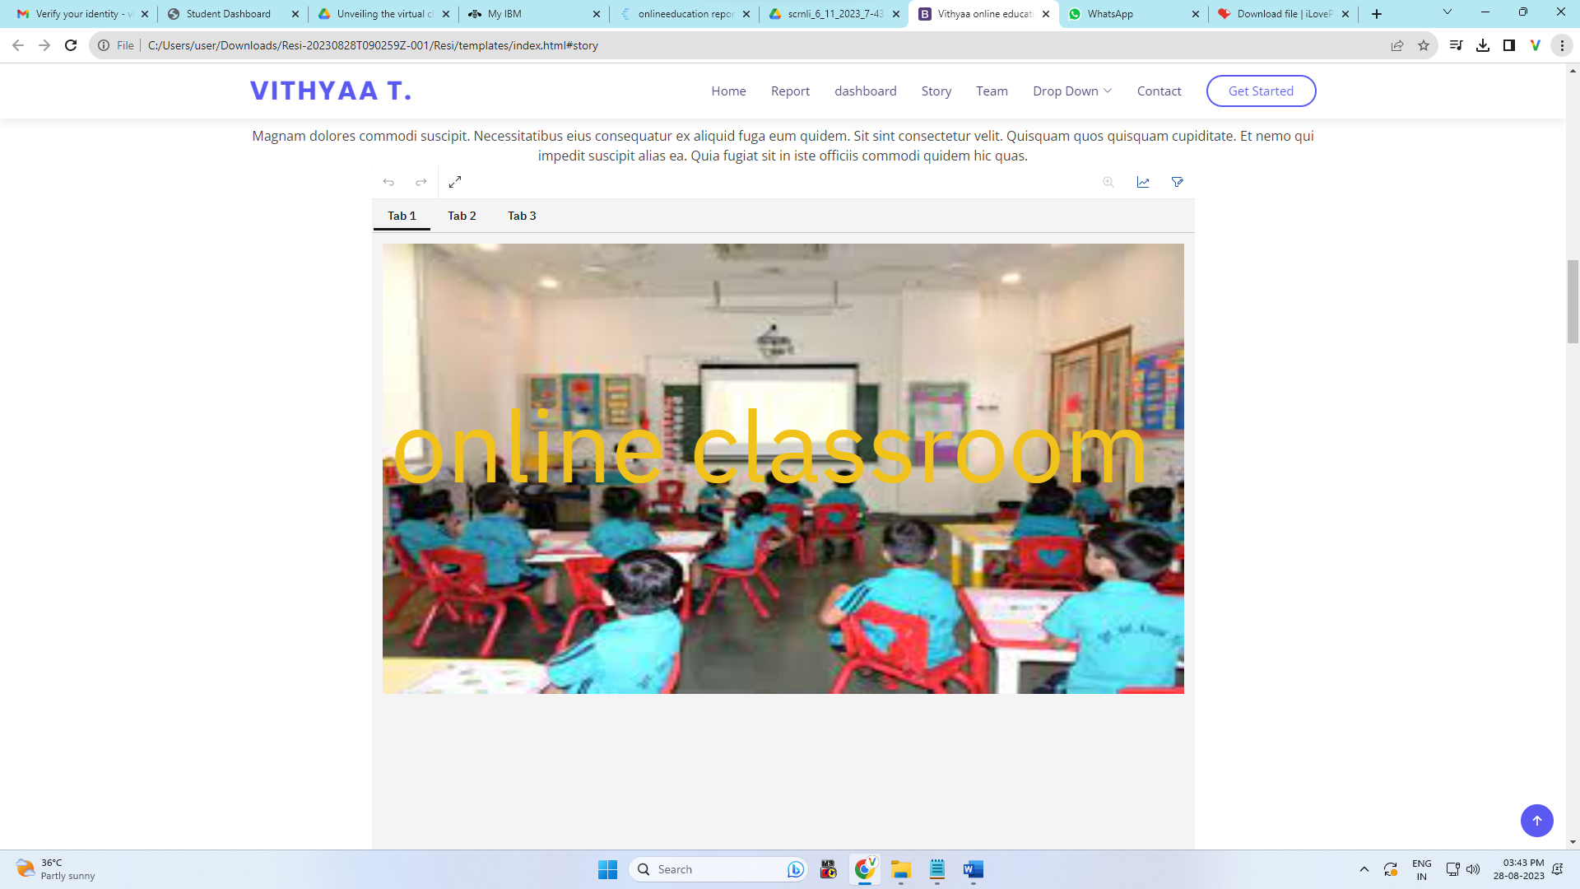

Figure 11. Screenshot of website showing the dashboard, report and story of the project implemented

# 7ADVANTAGES AND DISADVANTAGES:

Utilizing IBM Cognos Analytics to enhance online education offers numerous advantages. Educators gain data-driven insights that inform decisions on teaching methodologies, resource allocation, and student support, fostering more effective learning environments. Personalized learning experiences are facilitated through tailored paths based on student preferences, while predictive models enable timely interventions for struggling students, elevating success rates. Real-time monitoring via interactive dashboards enhances educators' ability to track student progress and course efficacy.

However, the proposed system has potential challenges, such as managing complex data integration, addressing privacy concerns, investing in training, and balancing technical skills with traditional teaching approaches. Careful consideration of these advantages and disadvantages is crucial for a successful integration that harnesses the platform's potential to advance online education.

# 8.APPLICATIONS:

IBM Cognos Analytics makes online learning better. It helps teachers understand how students are doing, create personalized learning plans, and help struggling students early. The platform also helps schools use resources wisely and track student progress. It uses cool pictures to show important information, helping teachers and schools make good decisions. It improves lessons, checks if they work, and includes everyone in learning. It also helps teachers learn new things and makes lessons fit each student. With IBM Cognos Analytics, online learning becomes more fun and effective.

9.**CONCLUSION**:

The analysis of the online education system, augmented by the insights derived from IBM Cognos Analytics, serves to underscore both its potential and challenges. Through this enhanced understanding, valuable insights are gained into the critical factors of student engagement, teacher training, and accessibility. By leveraging the power of IBM Cognos Analytics, data-driven strategies are unlocked to optimize these elements, thus elevating the overall effectiveness of virtual classrooms.

**10FUTURE** **SCOPE**

The future scope of utilizing IBM Cognos Analytics to enhance online education holds promising avenues for further advancements. The integration of AI capabilities holds the potential to use in a new era of adaptive learning platforms, seamlessly tailoring content and pacing to cater to each student's unique needs and learning patterns. Moreover, by extending data-driven insights to parents and stakeholders, a more engaged and collaborative educational ecosystem can emerge, enhancing students' online learning journeys. Furthermore, the integration of virtual reality (VR) and augmented reality (AR) technologies stands poised to revolutionize online education, offering immersive and interactive learning experiences that captivate and inspire learners in ways previously unexplored

# REFERENCES

1. Almahasees, Z., and Jaccomard, H. (2020). Facebook translation service (FTS) usage among jordanians during COVID-19 lockdown. Adv. Sci. Tech. Eng.

Syst. 5, 514–519. doi: 10.25046/aj050661

1. Cheng, G., and Chau, J. (2016). Exploring the relationships between learning styles, online participation, learning achievement and course satisfaction: An empirical study of a blended learning course. Br. J. Educ. Technol. 47, 257– 278. doi: 10.1111/bjet.12243
2. Dhawan, S. (2020). Online learning: a panacea in the time of COVID-19 crisis.

J. Educ. Technol. Syst. 49, 5–22. doi: 10.1177/0047239520934018

1. Nikdel Teymori, A., and Fardin, M. A. (2020). COVID-19 and educational challenges: a review of the benefits of online education. Ann. Milit. Health Sci.

Res. 18:e105778. doi: 10.5812/amh.105778

1. Gautam, P. (2020). Advantages and Disadvantages of Online Learning - eLearning Industry. Available online at: https://elearningindustry.com/advantages-and-disadvantages-online-learning (accessed December 1, 2020).